**Demonstarting XML and Xml Scheme Assertion**

It is used to validate mainly xml embedded in response.This assertion doesn’t require input.

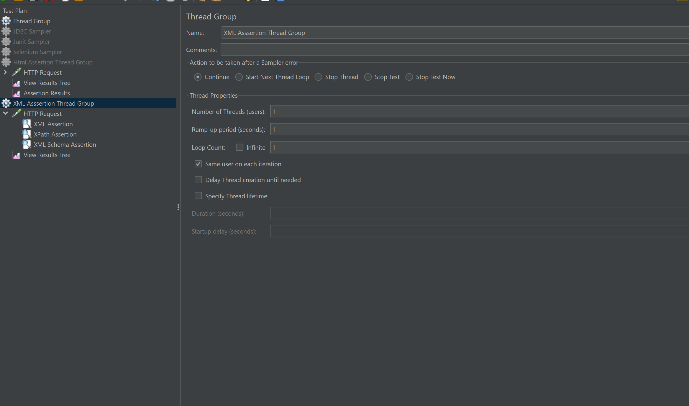

XML Scheme Assertion :

It is used to compare the xml assertion ..it validates the xml assertion.

